Project Design Phase-I
Solution Architecture

Date | 19 Decr 2026
Team ID | LTVIP2026TMIDS35041
Project Name | Measuring The Pulse Of Prosperity: An Index Of Economic Freedom Analysis
Maximum Marks | 4 Marks

Solution Architecture:
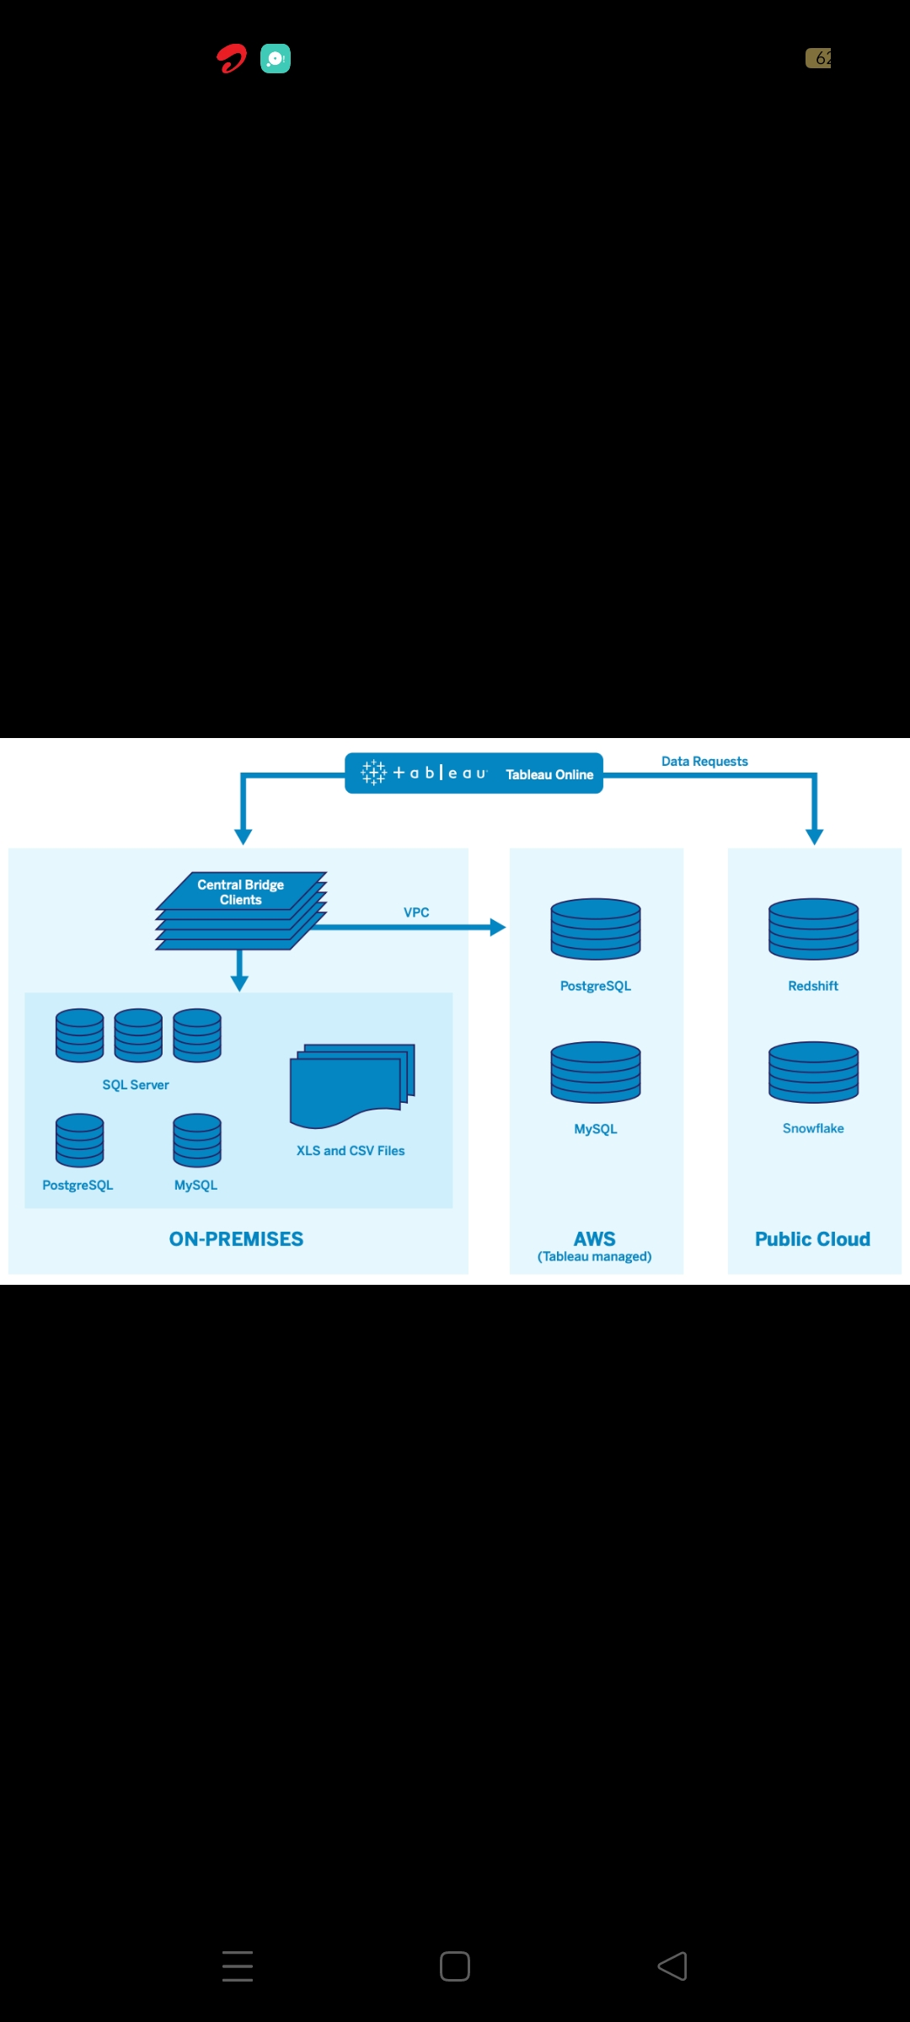
Figure 1: Architecture and Economic freedom analysis
The solution architecture defines how data flows from raw datasets to meaningful visual insights. In this project, the architecture bridges the gap betweeneconomic datasets and interactive visual analytics using Tableau.
The architecture is designed to:
Collect and organize global economic freedom data
Process and clean the dataset
Perform calculations such as SUM and AVERAGE
Visualize insights through dashboards and stories
Enable decision-making using interactive charts and maps
Key Components of the Architecture:
Data Source Layer
Economic Freedom Index dataset (2022)
Data includes country name, region, overall economic freedom score, GDP growth, inflation, unemployment, financial freedom, etc.
Data Pre-Processing Layer
Data cleaning (handling missing values)
Formatting numeric and categorical fields
Creating calculated fields (SUM, AVG, rankings)
Analytics & Processing Layer
Aggregations such as:
Country-wise scores
Region-wise average economic freedom
Sorting and ranking (Top 40, Bottom countries)
Correlation analysis (GDP, inflation, unemployment)
Visualization Layer (Tableau)
Bar charts (country-wise and region-wise)
Maps (global economic freedom visualization)
Dashboards (combined visual insights)
Stories (step-by-step narrative analysis)
Presentation & User Layer
Interactive dashboards
Story navigation for insights
Exporting reports and publishing to Tableau Public

